**Important Note**: pls take backup of configuration files when you going to change anything in configuration files.

Command: cp <source-file> <dest_file/location> ----- this will copy

mv <source-file> <dest_file> ----- it will rename file name.

**---------------------------------------**

**Ansible installation procedure**: (Before doing these steps, you should follow Ansible server setup document)

1. **In ansible_controler server:**

Enter into below file….



Find below path and replace with 1(one) instead of 0(zero) and save, exit. :wq!

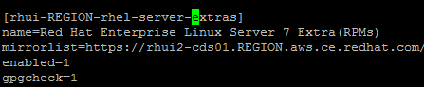

Install yum repo’s. in some cases it will install by default.



**OR**

**Run below commands if it is Linux 8 .**

RHEL/CentOS 8:

# yum install <https://dl.fedoraproject.org/pub/epel/epel-release-latest-8.noarch.rpm>

Install Ansibe



Check with below command whether ansible installed or not

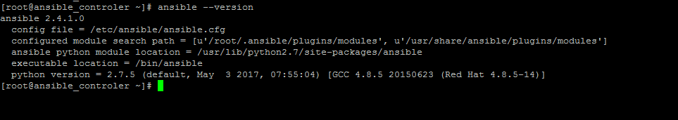

**2.In ansible_demo server:** Pls follow same steps which you have performed in ansible_controler server

**3. In ansible_controler server**

Go to below file: vi /etc/ansible/ansible.cfg

And uncomment **inventory** and **sudo_user** ( we should uncomment some more params. Those we will see later)

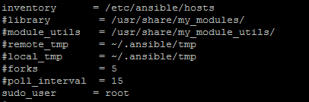

Go to below path



Rename your existing host file with new name ( i.e hosts.original)

Create new host file and enter your server details as shown below.

**Note**: you can mention group names as per your wish. like: prod, non_prod, web_servers , app_servers, db_servers, London_datacenter, newyork_datacenter

In this case I have mentioned local, demo1 and demo2

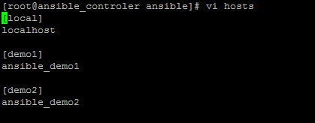

Now all is set.

Try to ping with ansible command from ansible_controler server.

